COMPARISON OF POPULATION MEANS

- One-Sample t-Test

In this type of problem we have a sample of continuous measurements of size n and
we consider the null hypothesis
$$H_{0}:μ=μ_{0}$$
where $μ_{0}$ is a fixed and known number.

Weight Gain: One sample t-test
Description:
This data set, "Weight Gain", provides weights of 16 participants before and after an eight-week period of excessive calorie intake (Moore et al., 2012, p. 425).
Variables:
- Weight Before - Weight in pounds (lb) measured before eight weeks of excessive calorie intake.
- Weight After - Weight in pounds (lb) measured after eight weeks of excessive calorie intake.
- Difference - Weight After - Weight Before.
This example JASP file demonstrates the use of one sample t-test. We will test the hypothesis that 1000 excess calorie intake per day over 8 weeks results in 16 pounds (approximately 7.2 kilograms) weight increase.
References:
Moore, D. S., McCabe, G. P., and Craig, B. A. (2012). Introduction to the Practice of Statistics (7th ed.). New York: Freeman.
Levine, J. A., Eberhardt, N. L., and Jensen, M. D. (1999) Role of nonexcercise activity thermogenesis in resistance to fat gain in humans. Science, 283:212-214.

Assumption Checks

Assumption 1. There are no extreme outliers in the distribution of dependent variable, as assessed by visual inspection of boxplot.

Difference
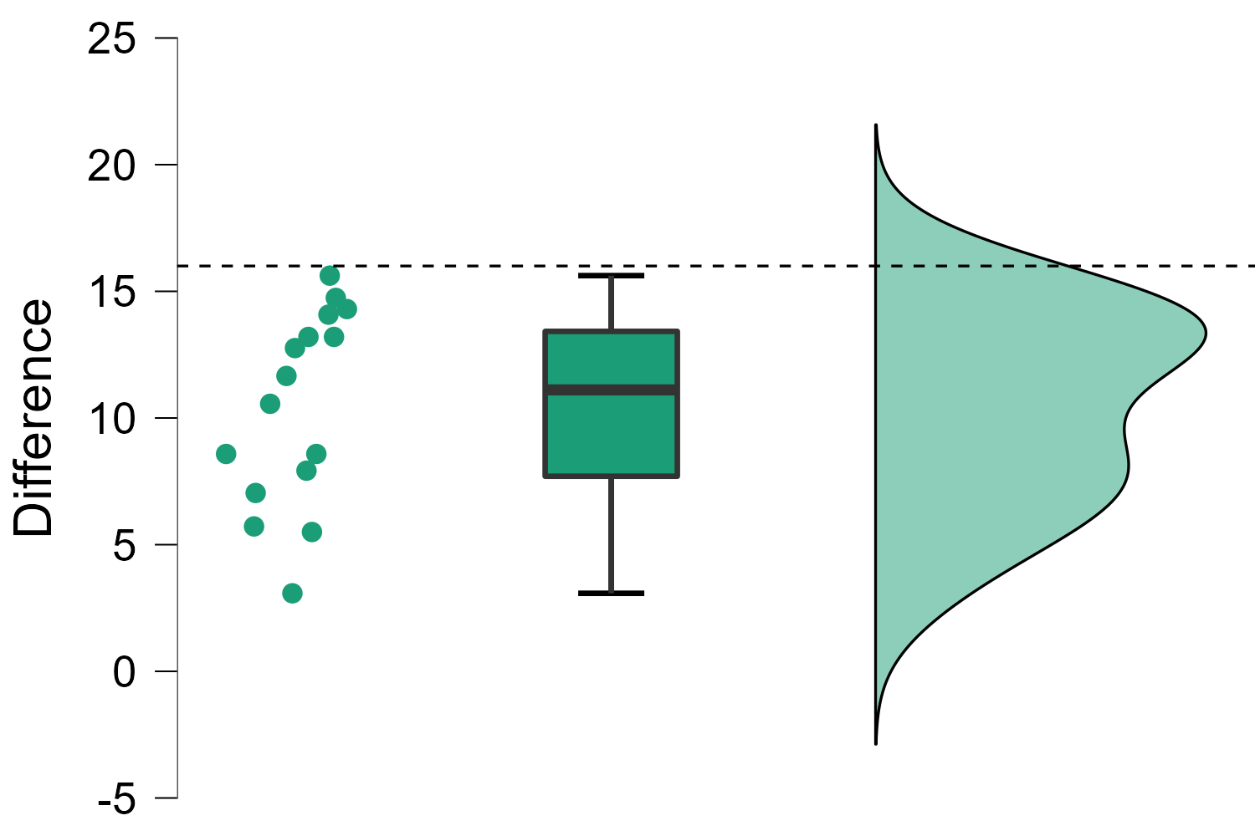

Remark. There are no significant outliers, as assessed by inspection of the boxplot of the differences in weight before and weight after.

Assumption 2. The dependent variable is approximately normally distributed.
Test of Normality (Shapiro-Wilk)
 |  | W |  | p
Difference |  | 0.938 |  | 0.325
Note. Significant results suggest a deviation from normality.

Remark. The assumption of normality is not significant (p = 0.325). Hence, our dependent variable (Difference) is normally distributed, as assessed by Shapiro-Wilk test.

Descriptive Statistics
Descriptive Statistics
 | Difference
Valid |  | 16
Missing |  | 0
Mean |  | 10.409
Std. Error of Mean |  | 0.960
Std. Deviation |  | 3.841
Minimum |  | 3.080
Maximum |  | 15.620
We can see that the mean of the difference in weight gain is 10.41 pounds. The standard deviation is almost 4 pounds (3.841), which is quite large.

One Sample T-Test
 |  |  |  |  |  |  |  |  |  | 95% CI for Mean Difference
 |  | t |  | df |  | p |  | Mean Difference |  | Lower |  | Upper
Difference |  | 5.823 |  | 15 |  | < .001 |  | 5.591 |  | 3.545 |  | 7.638
Note. For the Student t-test, location difference estimate is given by the sample mean difference d .
Note. For the Student t-test, the alternative hypothesis specifies that the mean is different from -16.
Note. Student's t-test.

Null hypothesis
$$H_{0}:μ=16$$
The results indicate that the data are very unlikely to arise if the mean gain of weight in the population was 16 pounds (t(15) = 5.823, p < 0.001). We can thus reject the null hypothesis.

- Analysis of Pair-Matched Data

Basic requirements of the paired-samples t-test

In order to run a paired-samples t-test, there are four assumptions that need to be considered. The first two relate to your choice of study design and the nature of your data, whilst the second two relate to the paired-samples t-test itself:
- You have one dependent variable that is measured at the continuous (i.e., ratio or interval) level.
- You have one independent variable that consists of two categorical, related groups or matched pairs (i.e., a dichotomous variable).
- There should be no significant outliers in the differences between the two related groups.
- The distribution of the differences of the dependent variable between the two related groups should be approximately normally distributed.

Moon and Aggression: Paired Samples T-Test
Description:
This data set, "Moon & Aggression", provides the number of disruptive behaviors by dementia patients during two different phases of the lunar cycle (Moore et al, 2012, p. 410). Each row corresponds to one participant.
Variables:
- Moon - The average number of disruptive behaviors during full moon days.
- Other - The average number of disruptive behaviors during other days.
This example JASP file demonstrates the use of paired samples t-test. Specifically, we will examine the adequacy of the null hypothesis which states that the average number of disruptive behaviors among patients with dementia does not differ between moon days and other days.
References:
Moore, D. S., McCabe, G. P., and Craig. B. A. (2012) Introduction to the Practice of Statistics (7th ed). New York: Freeman.
"These data were collected as part of a larger study of dementia patients conducted by Nancy Edwards and Alan Beck, Purdue University." (Moore et al, 2012, p. N-8).

Assumption Checks

Assumption 1. The difference between Moon and Other is measured at the continuous level.

Assumption 2. The independent variable (Phases of lunar cycle) has two related groups (Moon and Other).

Assumption 3. Absence of outliers

Boxplots

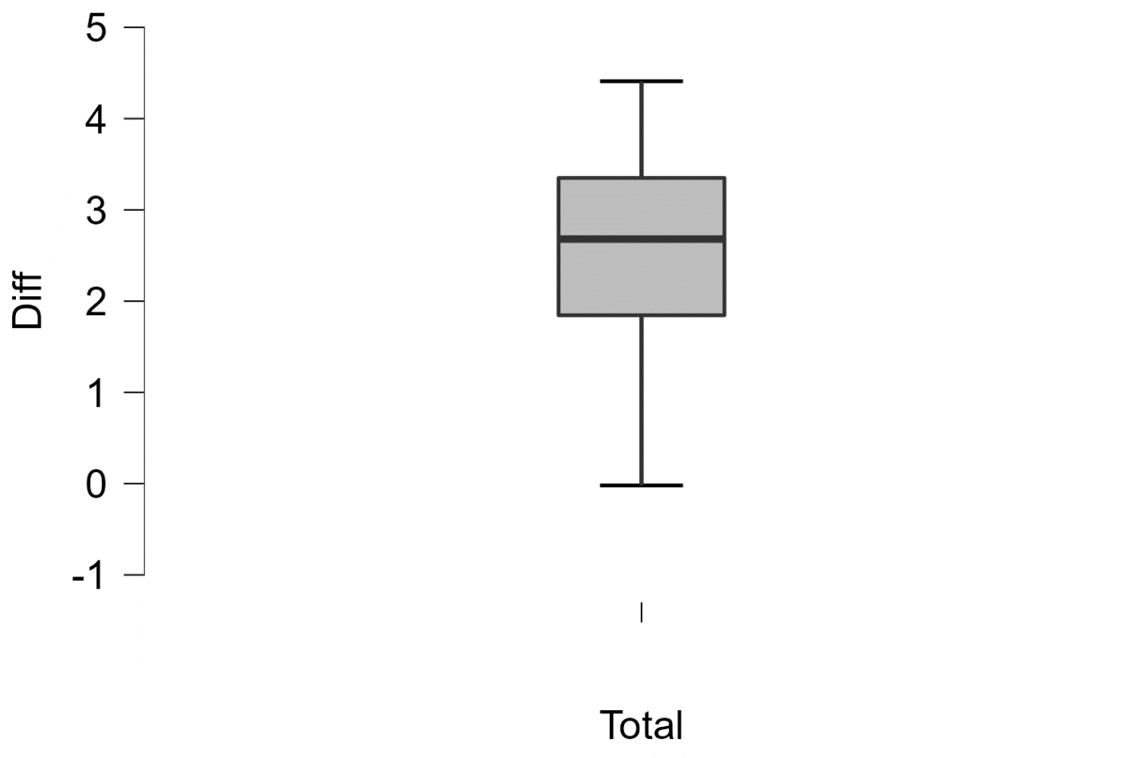

Remark. There are no extreme outliers, as assessed visual inspection of boxplot of differences between the two related groups (Moon and Other).
Assumption 4. Normality of differences between two related groups.

Test of Normality (Shapiro-Wilk)
 |  |  |  |  |  | W |  | p
Moon |  | - |  | Other |  | 0.913 |  | 0.148
Note. Significant results suggest a deviation from normality.

Remark. The assumption of normality of differences is not significant. We provisionally retain the null hypothesis that the data are normally distributed.

Descriptives
During full moon days, patients show disruptive behavior more frequently than during other days.

Descriptives
 |  | N |  | Mean |  | SD |  | SE
Moon |  | 15 |  | 3.022 |  | 1.499 |  | 0.387
Other |  | 15 |  | 0.589 |  | 0.445 |  | 0.115

Moon - Other
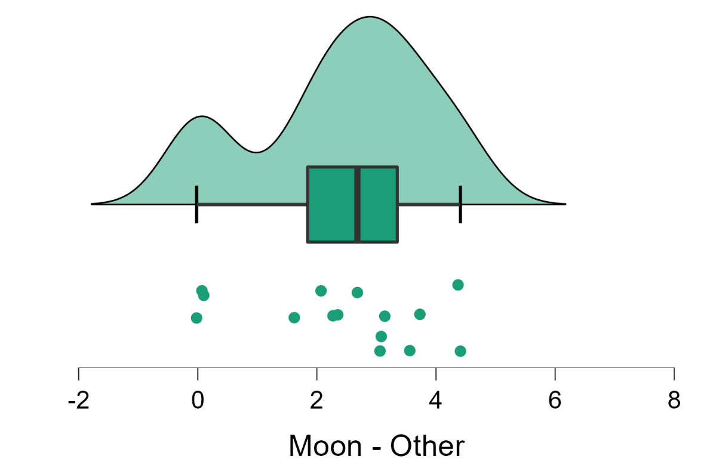

Descriptives Plots

Moon - Other
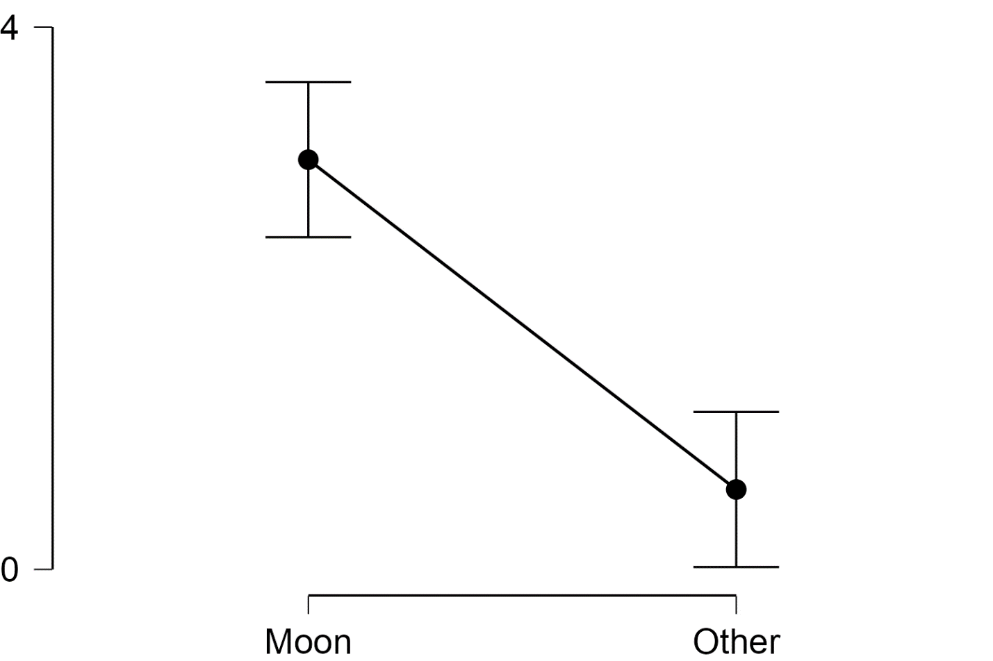

Paired Samples T-Test
Paired Samples T-Test
Measure 1 |  |  |  | Measure 2 |  | t |  | df |  | p |  | Mean Difference |  | SE Difference
Moon |  | - |  | Other |  | 6.452 |  | 14 |  | < .001 |  | 2.433 |  | 0.377
Note. Student's t-test.
The paired samples t-test suggests that the data (or more extreme) are unlikely to occur if the average number of disruptive behaviors was the same during full moon days and other days.

- Comparison of Two Means

Basic requirements of the independent-samples t-test
In order to run an independent-samples t-test, there are six assumptions that need to be considered. The first three assumptions relate to your choice of study design and the measurements you chose to make, whilst the second three assumptions relate to the characteristics of the data that you actually collected. These assumptions are:
- You have one dependent variable that is measured at the continuous level.
- You have one independent variable that consists of two categorical, independent groups (i.e., a dichotomous variable).
- You should have independence of observations, which means that there is no relationship between the observations in each group of the independent variable or between the groups themselves.
- There should be no significant outliers in the two groups of your independent variable in terms of the dependent variable.
- Your dependent variable should be approximately normally distributed for each group of the independent variable.
- You have homogeneity of variances (i.e., the variance of the dependent variable is equal in each group of your independent variable).

Invisibility Cloak: Independent samples t-test

This data set, "Invisibility Cloak", provides the number of mischievous acts committed by two groups of people, those with and those without an invisibility cloak.
Variables:
- Participant - Identification number of a participant.
- Cloak - Experimental group (0 = without a cloak of invisibility, 1 = with a cloak of invisibility).
- Mischief - the number of mischievous acts committed by a participant.
This example JASP file demonstrates the use of an independent samples t-test. Specifically, we examine the adequacy of the null hypothesis that the Invisibility Cloak has no effect on the number mischievous acts committed.
Reference:
Field, A. P. (2017). Discovering Statistics Using IBM SPSS Statistics (5th ed.). London: Sage. [Fictional data set]
Assumptions Checks

Assumption 1. The dependent variable (Mischief) is a continuous level.
Assumption 2. The independent variable (Cloak) consists of two categorical, independent groups (With a cloak, Without a cloak).
Assumption 3. Each participant is present to only one group.

Raincloud Plots

Mischief
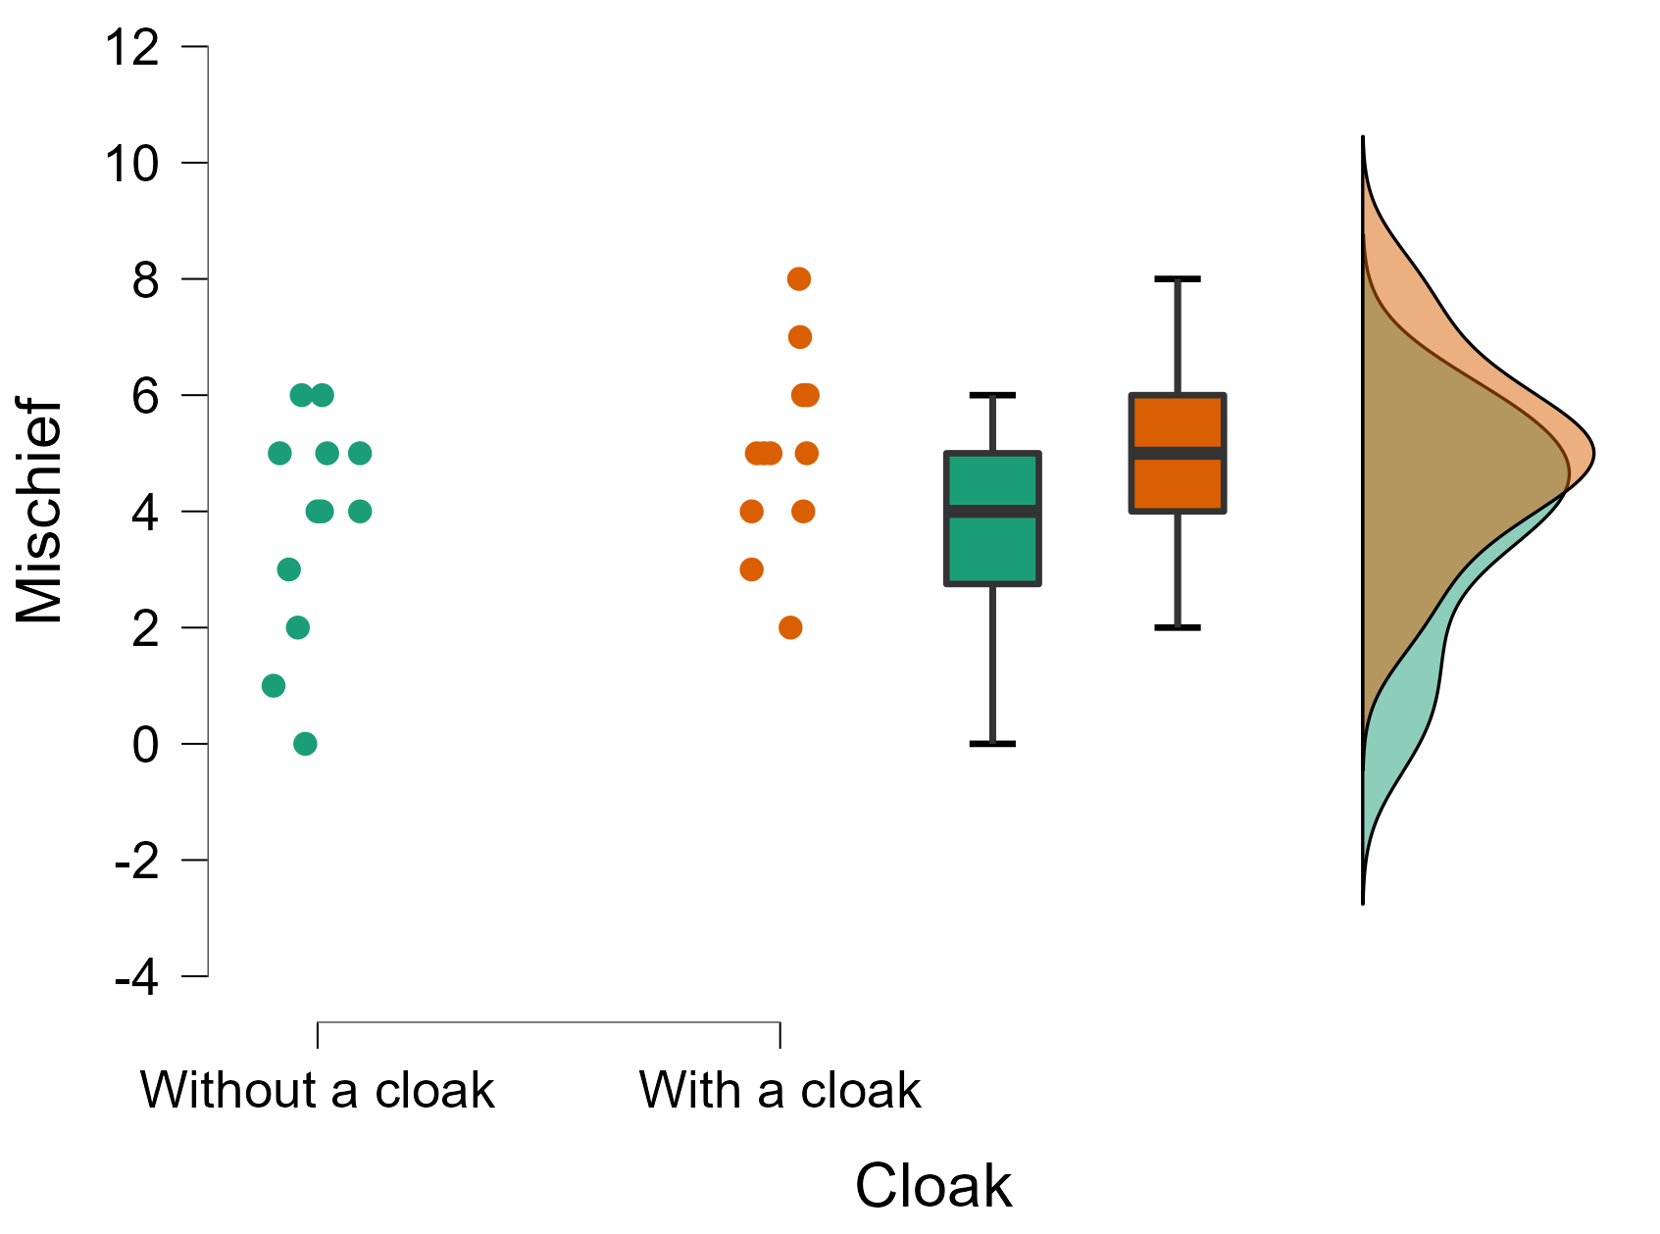

Assumption 4. Outliers. There are no significant outliers in the two groups of independent variable (Cloak) in terms of the dependent variable (Mischief), as assessed by visual inspection of boxplots.

Assumption 5. Normality. The dependent variable (Mischief) for each group (Cloak) is normally distributed (p > 0.05), as assessed by Shapiro-Wilk test.

Test of Normality (Shapiro-Wilk)
 |  |  |  | W |  | p
Mischief |  | Without a cloak |  | 0.913 |  | 0.231
 |  | With a cloak |  | 0.973 |  | 0.936
Note. Significant results suggest a deviation from normality.

Assumption 6. Homogeneity of variances. There is equality of variances between groups (Without a cloak, With a cloak) on their number of mischievous acts (Mischief), as assessed by Levene’s test of equality of variances.

Test of Equality of Variances (Levene's)
 |  | F |  | df |  | p
Mischief |  | 0.545 |  | 1 |  | 0.468

Computation

Independent Samples T-Test
 |  |  |  |  |  |  |  |  |  |  |  | 95% CI for Mean Difference
 |  | t |  | df |  | p |  | Mean Difference |  | SE Difference |  | Lower |  | Upper
Mischief |  | -1.713 |  | 22 |  | 0.101 |  | -1.250 |  | 0.730 |  | -2.763 |  | 0.263
Note. Student's t-test.

This table shows the output for the independent samples t-test. The differences between the groups are not statistically significant at the .05 level, which means that the data do not provide much motivation to reject the null hypothesis.

Mischief
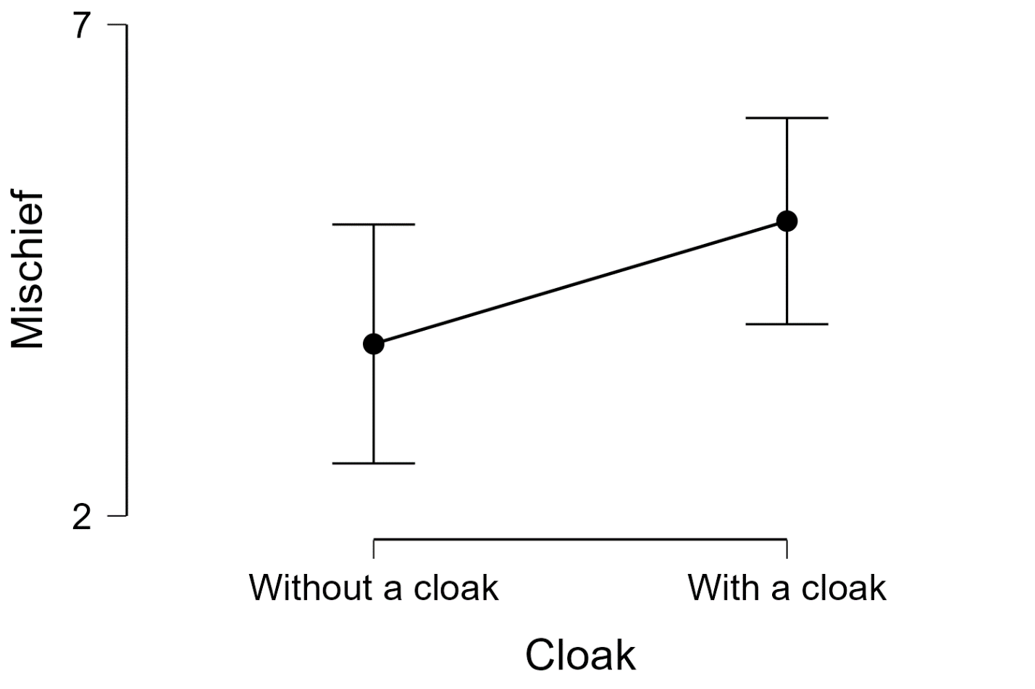

Null hypothesis
$$H_{0}:μ_{1}=μ_{2}$$

There is no significant difference between With a Cloak and Without a Cloak on their number of mischievous acts.

- One-Way Analysis of Variance (ANOVA)

The ANOVA test (or Analysis of Variance) is used to compare the mean of multiple groups. The term ANOVA is a little misleading. Although the name of the technique refers to variances, the main goal of ANOVA is to investigate differences in means.

One-way ANOVA: an extension of the independent samples t-test for comparing the means in a situation where there are more than two groups. This is the simplest case of ANOVA test where the data are organized into several groups according to only one single grouping variable (also called factor variable). Other synonyms are: 1 way ANOVA, one-factor ANOVA and between-subject ANOVA.

You will learn how to:
- Compute and interpret the different types of ANOVA in R for comparing independent groups.
- Check ANOVA test assumptions
- Perform post-hoc tests, multiple pairwise comparisons between groups to identify which groups are different.
- Visualize the data using box plots, add ANOVA and pairwise comparisons p-values to the plot.

Basics
Assume that we have 3 groups to compare, as illustrated in the image below. The dashed line indicates the group mean. The figure shows the variation between the means of the groups (panel A) and the variation within each group (panel B), also known as residual variance.

The idea behind the ANOVA test is very simple: if the average variation between groups is large enough compared to the average variation within groups, then you could conclude that at least one group mean is not equal to the others.

Thus, it’s possible to evaluate whether the differences between the group means are significant by comparing the two variance estimates. This is why the method is called analysis of variance even though the main goal is to compare the group means.

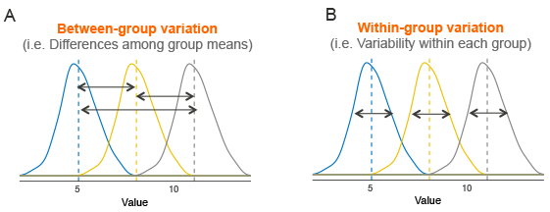
Briefly, the mathematical procedure behind the ANOVA test is as follow:
- Compute the within-group variance, also known as residual variance. This tells us, how different each participant is from their own group mean (see figure, panel B).
- Compute the variance between group means (see figure, panel A).
- Produce the F-statistic as the ratio of variance.between.groups/variance.within.groups.

Note that, a lower F value (F < 1) indicates that there are no significant difference between the
means of the samples being compared.

However, a higher ratio implies that the variation among group means are greatly different from each other compared to the variation of the individual observations in each groups.

Reference. ANOVA in R. Retrieved from https://www.datanovia.com/en/lessons/anova-in-r/

Pain Thresholds: One-way ANOVA
Description: This data set, "Pain thresholds", provides pain threshold for people with different hair color.
Variables:
- V1 - Participant number.
- Hair Color - Hair color of the participant (`Light Blond' = light blond, `Dark Blond' = dark blond, `Light Brunette' = light brunette, `Dark Brunette' = dark brunette).
- Pain Tolerance - Performance on pain sensitivity test (the higher the score, the better the pain tolerance).
This example file demonstrates the use of one-way ANOVA. We will conduct the classical version of the analysis.
Reference:
McClave, J. T. and Dietrich, F. H. (1991). Statistics. San Francisco: Dellen publishing.

